

**Database Design & Development**

**10204282  
A/618/7400**

**Section (3)**

**Developing a Database System**

**Submitted to**

Dr. Raneem Qaddoura

**Submitted on**

June 20th, 2023

**Submitted by**

Marwan Tareq Shafiq Al Farah

**Student ID**

21110011

**Spring 2022 - 2023**

**Table of Content**

***User Documentation*** 3

**Introduction** 3

**Using the System** 4

**Frequently Asked Questions** 11

**Contact Information** 12

# ***User Documentation***

**Introduction:**

The IHDB (Ibn Al Haitham Database) system is a sophisticated relational database developed to help Ibn Al Haitham Hospital manage and retrieve patient information, surgeries, doctors’ schedules, and operating room details more efficiently. This section gives an overview of the system’s functioning and features to help doctors become acquainted with its options.

The IHDB system anticipates to improve doctors’ productivity by offering easy access to vital patient data and surgical information. It allows doctors to arrange their appointments more quickly, check patient information, obtain operation data, and get operating room information.

The following are the primary characteristics and benefits of the IHDB system for doctors:

* **Centralized Patient Data:** Doctors may easily access patient data such as demographics, contact information, and medical history to deliver better-informed treatment.
* **Appointment Management:** The system enables doctors to monitor and manage their appointment calendars, including the ability to reschedule appointments as needed.
* **Surgery Details:** Doctors may access detailed information on surgeries, such as surgical procedures, patient information, operating room assignments, and planned timings.
* **Operating Room data:** The system gives access to operating room data such as room numbers, room kinds, and capacities to aid doctors in properly planning and scheduling procedures.
* **Efficient Data Retrieval:** The IHDB system provides fast and dependable data retrieval capabilities, allowing surgeons to quickly retrieve the necessary patient information and surgical specifics.
* **User-Friendly Interface:** The system’s graphical user interface (GUI) is meant to be intuitive and user-friendly, allowing for simple navigation and efficient interaction with the system.

Doctors have distinct user roles and related privileges in the IHDB system. These privileges determine the system operations that doctors may execute, such as examining patient information, organizing appointments, and obtaining surgical data. This documentation’s User Interface section contains thorough information on the various features and access privileges for doctors.

Doctors may successfully use the IHDB system’s capabilities to better their everyday workflows and deliver optimal treatment to patients by knowing the system overview and major features.

**Using the System:**

The IHDB (Ibn Al Haitham Database) system offers doctors with an easy-to-use graphical user interface (GUI) for managing patient information, appointments, and surgical details. This section outlines the many sites, rights, and features that doctors have access to inside the system.

To access the IHDB system, launch your web browser and type <http://localhost/Interface/index.php> into the address bar. This will lead you to the login page, where you input your login information to access the system.

1. **The Home Page:**

The Home Page is the primary page of the interface, from which doctors can select one of the five pages listed below:

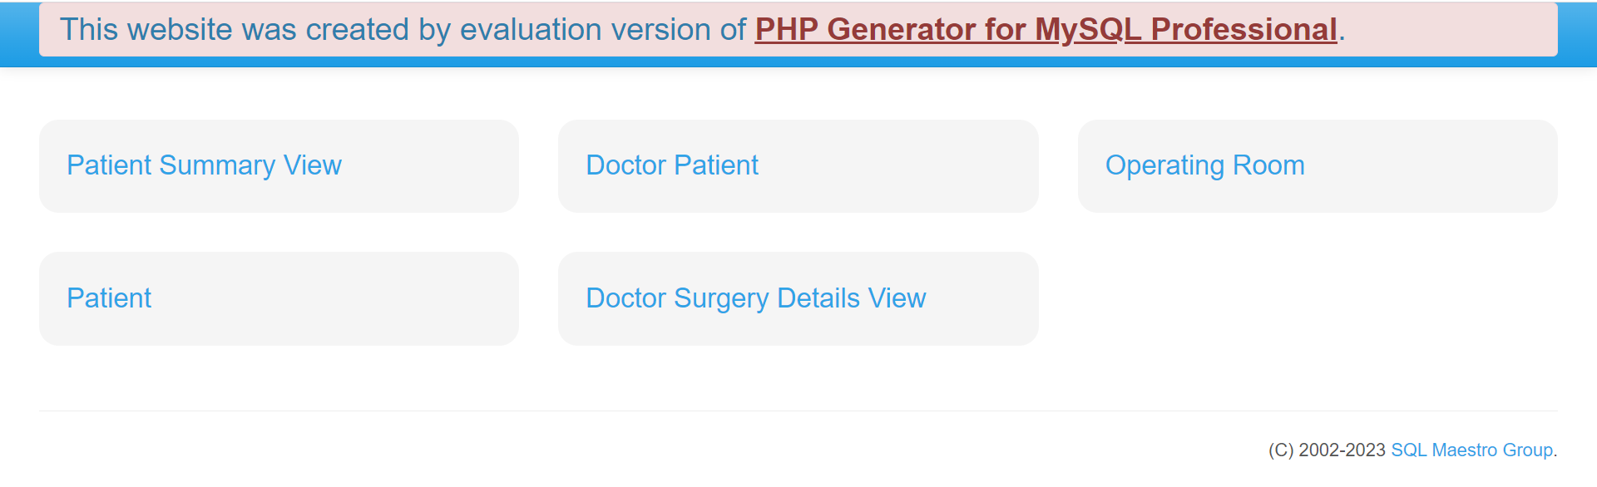

Figure 1 – The Home Page

The Home Page displays the five pages it can direct you to: Patient Summary View, Doctor Patient, Operating Room, Patient, and Doctor Surgery Details View. By clicking on these tables, you will be automatically directed to the corresponding page that will contain the information you want to access.

1. **Patient Summary View:**

The Patient Summary View page provides doctors with an overview of all patients in the IHDB system. It combines data from the Patient and Patient Allergy databases and outputs them in the form of a table. Doctors may access demographics, contact information, and allergies for their patients.

**Privileges:**

* Doctors have access to view the patient information in this table.

**Actions:**

* Doctors can search the list of patients for information such as demographics, contact information, and known allergies.

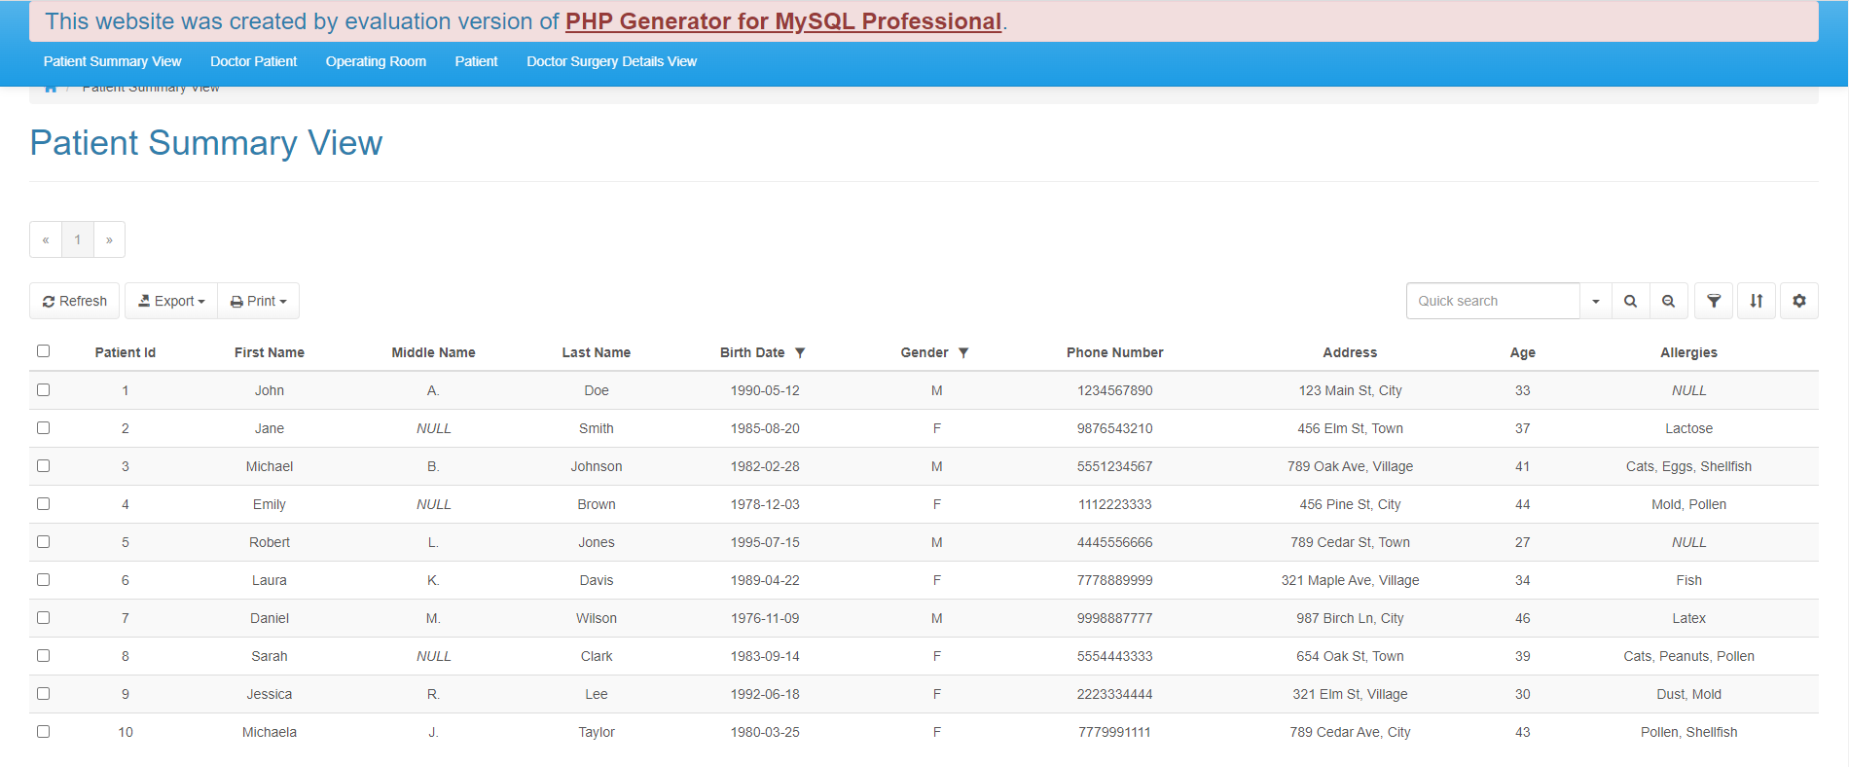

Figure 2 – The Patient Summary View Table

1. **Doctor Patient:**

This page shows the relationship between doctors and patients, as well as their appointment dates and times.

**Privileges:**

* Doctors have full access to this table, including the ability to select, update, insert, and delete data from this table.

**Actions:**

* Doctors can view a list of appointments that have been allocated to them, including the patient names and planned dates.
* Doctors can change appointment dates and times as required.
* Doctors can schedule new appointments for their patients on certain days and hours.
* Appointments that need to be canceled or rescheduled can be deleted by doctors.

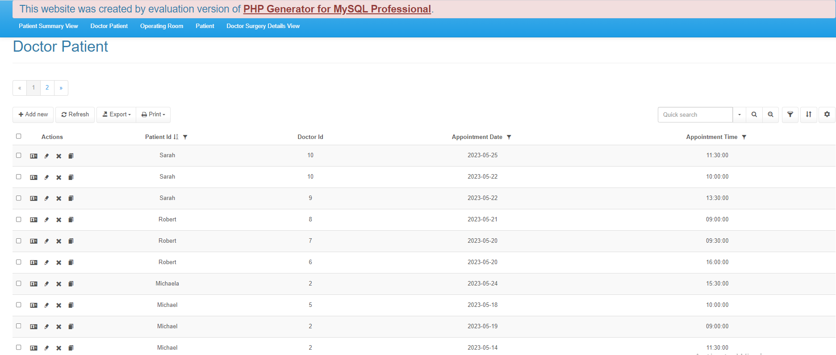

Figure 3 – The Doctor Patient Table

1. **Operating Room:**

The Operating Room page contains information about the available operating rooms, such as room numbers, room types, and capacities.

**Privileges:**

* Doctors have the select privilege on the Operating_Room table, which gives them access to operating room information.

**Actions:**

* Doctors may view a list of operating rooms, including their room numbers, types, and capacity. This data assists doctors in properly planning and scheduling procedures.

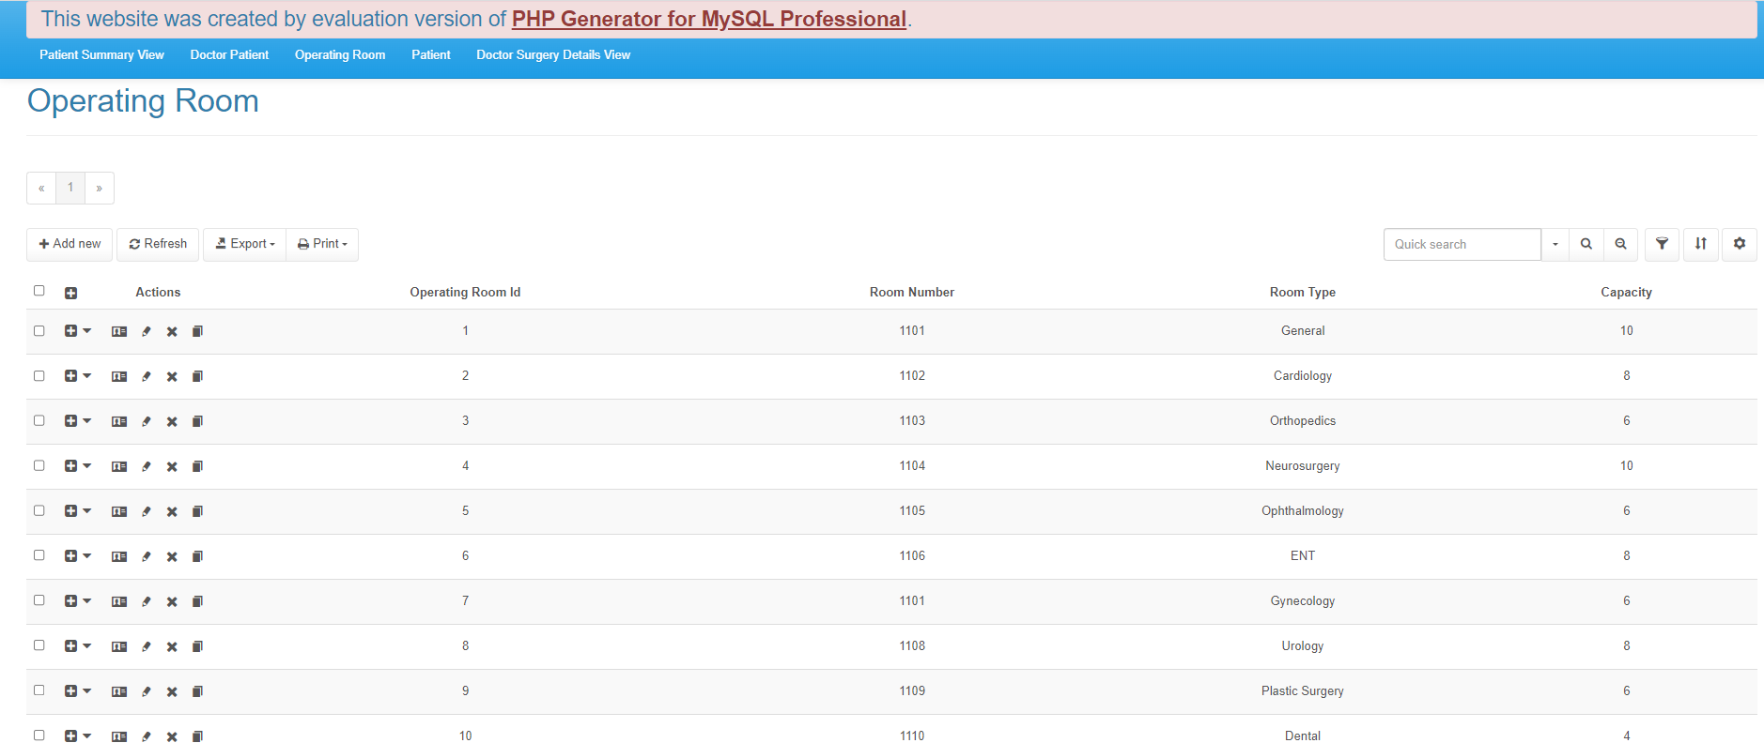

Figure 4 – The Operating Room Table

1. **Patient:**

The Patient page displays information on patients that have been saved in the system, such as IDs, names, birth dates, genders, phone numbers, and addresses.

**Privileges:**

* Doctors have full access to the Patient table, allowing them to manage patient data.

**Actions:**

* Doctors may obtain patient details such as names, birth dates, genders, phone numbers, and addresses by searching for individual patients or browsing through the list.
* Doctors can change patient information, such as contact information or demographic information.
* Doctors can input new patients’ information into the system and add them to the system.
* When required, doctors can delete patient records.

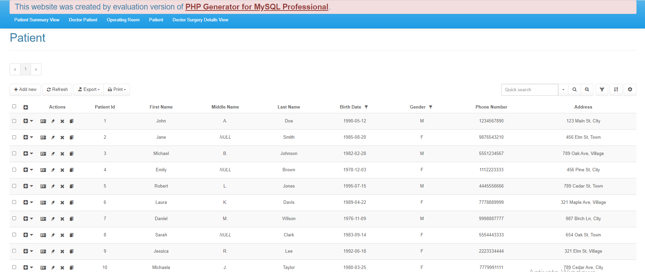

Figure 5 – The Patient Table

1. **Doctor Surgery Details View:**

The Doctor Surgery Details View feature gives doctors a detailed breakdown of their surgical schedules. It combines data from the Surgery, Patient, and Operating_Room databases. Doctors may see information including surgery type, start and end times, patient names, and operating room specifics.

**Privileges:**

* Doctors get access to view, select and search through their surgery information.

**Actions:**

* Doctors may get a summary of their scheduled procedures, including surgery kinds, start and finish timings, patient names, and the operating rooms allocated to them. This data assists doctors in successfully managing their surgery schedules.

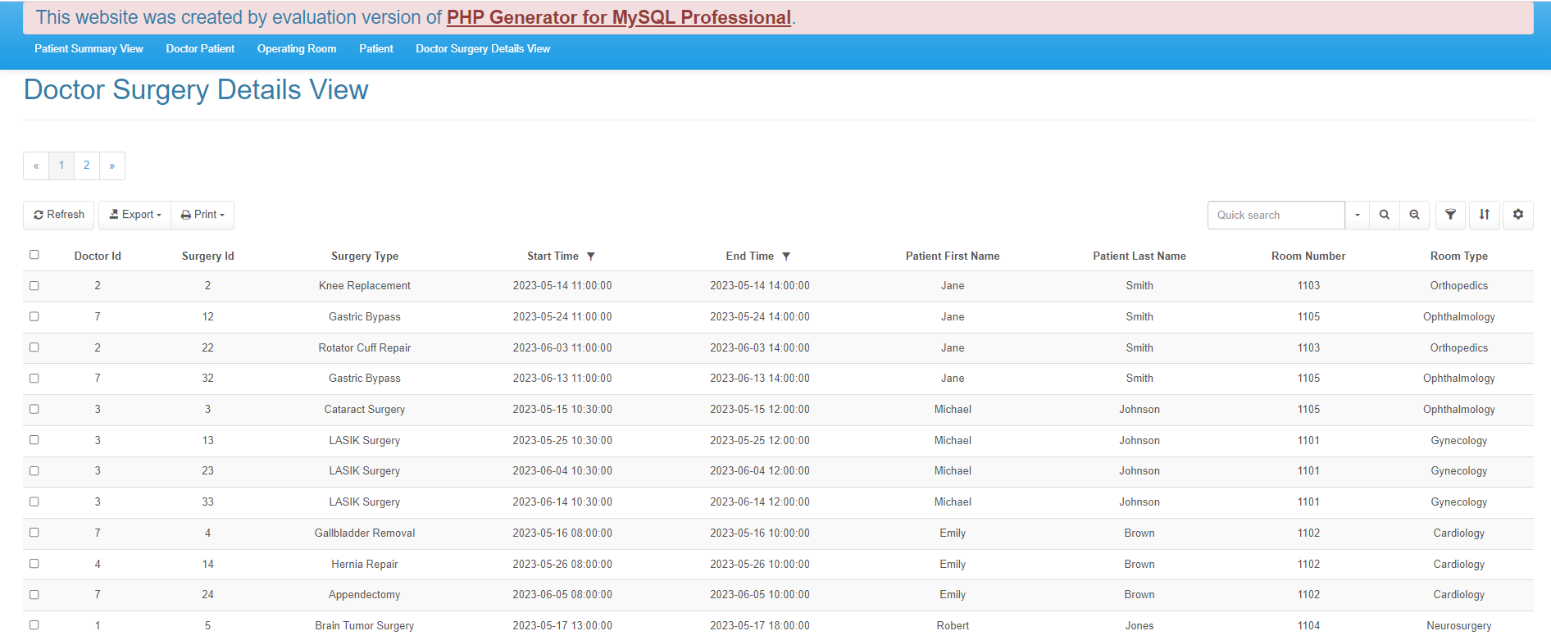

Figure 6 – The Doctor Surgery Details View Table

The IHDB system gives doctors particular permissions to conduct certain tasks on various pages. Doctors may conveniently handle patient information, appointments, and surgery specifics inside the system by exploiting these privileges and functions.

For more thorough instructions on utilizing each page and its individual functions, including step-by-step guidelines for conducting tasks such as updating patient records, entering appointments, and viewing surgical information, the following section will go step by step on how to do these operations:

1. **Inserting Data into a Table:**

In order to insert a new row into a table that the doctor has the insert privilege to, you should click on the  button on the top-left corner of the page which will transfer you to a new page where you enter the new data that you want to enter:

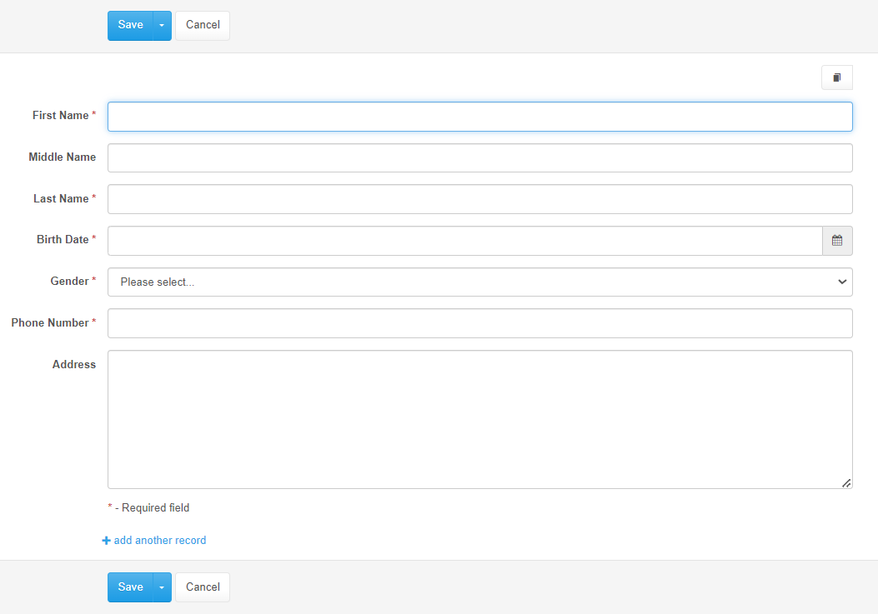

in order to add the new row to the table.

1. **Updating Data in a Table:**

In order to update a row in a table that the doctor has the update privilege to, you should click on the  pen button in the Action section of the row you want to update which will transfer you to a new page where you update the data:

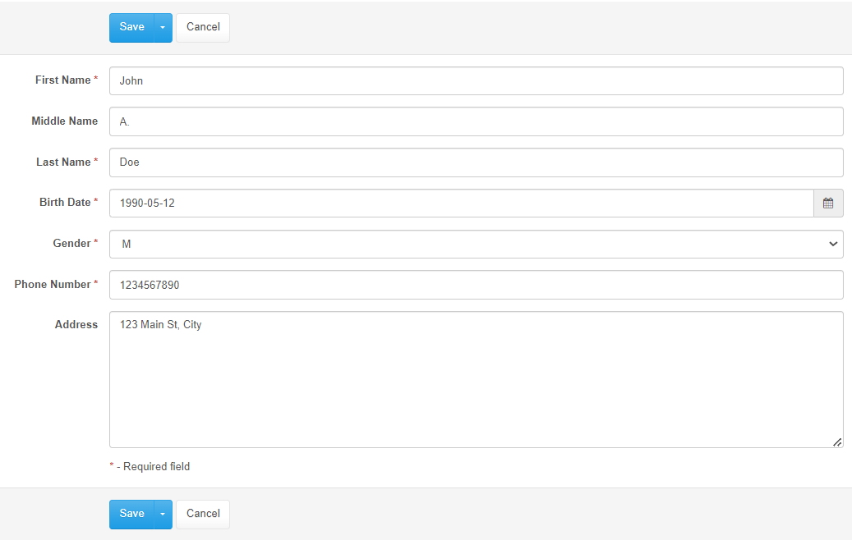

in order to save the new updates to the table.

1. **Deleting Data from a Table:**

In order to delete a row from a table that the doctor has the delete privilege to, you should click on the  X button in the Action section of the row you want to delete which will show you the following message:

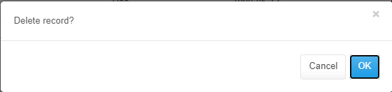

in order to delete that row.

1. **Searching for Data in a Table:**

In order to search for a row from a table that the doctor has the select privilege to, you should click on this button  on the top-right corner of the page which will show you the following message:

and it should return the wanted rows.

**Frequently Asked Questions:**

**FAQ 1:** How do I look for information on a certain patient?

**Answer:** You must navigate to the “Patient” page from the home page to search for information on a specific patient. On the “Patient” page, you can either scroll through the table to find the patient you’re looking for or use the filter button at the top right of the page to look for them using their ID, name, etc.

**FAQ 2:** How do I change a patient’s contact information?

**Answer:** To change a patient’s contact information go into the “Patient” page from the home page, then click “Edit” or “Update” in the row you want to alter and fill it up with the necessary contact information, such as a phone number or address, and then save the changes to the system.

**FAQ 3:** How do I reschedule a patient’s appointment?

**Answer:** To reschedule a patient’s appointment go into the “Doctor Patient” page from the home page. Then click on “Add New” and enter the doctor’s ID, the patient’s ID, the appointment date and time and then click on “Save”. You will notice that a new entry was added to the table, denoting the appointment that was just scheduled. To update an appointment’s date or time simply click on “Edit” or “Update” in the row that you want to update and repeat the above process.

**FAQ 4:** Where can I find an overview of my surgical schedules?

**Answer:** From the main page, navigate to the “Doctor Surgery Details View” page to see an overview of your surgical dates. This page provides a detailed summary of your scheduled procedures, including surgery kinds, start and end timings, patient names, and operating rooms. It gives you a simple way to monitor and track your surgical actions within the IHDB system.

**Contact Information:**

If you have any inquiries about the IHDB (Ibn Al Haitham Database) system, require assistance, or require technical support, kindly get in touch with our staff members as we are here to ensure a satisfying user experience and to provide help as quickly as we can.

**Email Support:** [support@ihdbhospital.com](mailto:support@ihdbhospital.com)

**Phone:** +962 7 7013 7361

We appreciate your comments and suggestions for enhancing the IHDB system. If you have any suggestions or comments, please email them to [feedback@ihdbhospital.com](mailto:feedback@ihdbhospital.com).

Thank you for going with the IHDB system. We are dedicated to providing you with dependable healthcare management solutions.